* 23-NTU-CS-1059 M.AHMAD SATTAR
* 23-NTU-CS-1068 M.HASAN ZUBAIR
* 23-NTU-CS-1072 M.SAAD EHTISHAM

# DATABASE PROJECT

**Social Media App**

**Business Rules:**

1. **User Registration:**

- Each user can only have one profile.. –

2. **User Profiles:**

- Users and pages can create posts. - Posts can contain text content and are timestamped. - Users can like and comment on posts..

3. **Pages:**

- Only registered users can create pages. - Each page must have a unique name. - Pages display posts made by the page and list followers.

4. **Posts:**

- Users must register with a unique username.

5. **Comments:**

- Only registered users can comment on posts. - Comments must be attributed to the commenting user..

6. **Reactions:**

- Users can react to posts and comments with predefined reactiontypes(like, love, etc.)..

### Example Scenario Rules ###

1. **Creating a Post:**

- A user can create a post by providing text content. - The post must be attributed to the user and include a timestamp.

2. **Reacting to a Post:**

- A user can react to a post with a predefined reaction type. - The reaction is recorded and associated with the user and thepost. - The user can change their reaction at any time, updating the record.

**ER DIAGRAM:**

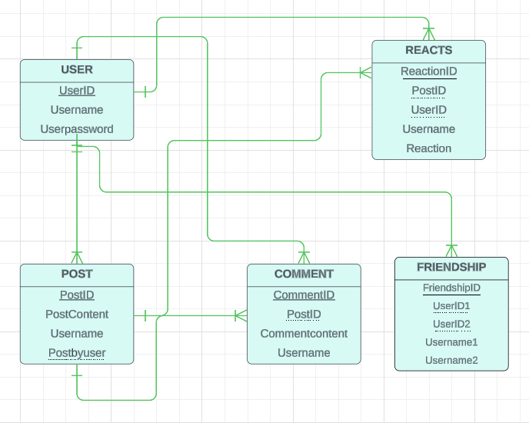

**TABLES FROM ERD:**

## USER TABLE

|  |  |  |
| --- | --- | --- |
| Username | Userpassword | Username |

## 

## POST TABLE

|  |  |  |  |  |
| --- | --- | --- | --- | --- |
| PostID | Postcontent | | Postbyuser (UserID) | Username |
| REACT TABLE | | | |  | | |  |  |
| ReactionID | | Reactbyuser  (UserID) | | Username | |  | PostID | Reaction |

## COMMENT TABLE

|  |  |  |  |
| --- | --- | --- | --- |
| CommentID | Username | CommentContent | PostID |

FRIENDSHIP

|  |  |  |  |  |
| --- | --- | --- | --- | --- |
| FriendshipID | UserID1 | UserID2 | Username1 | Username2 |

LIST OF FINAL ENTITIES :

* User
* Post
* Comment
* Friendship
* Reacts